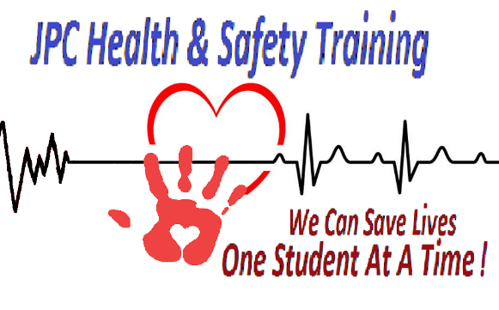

Contractor application

Application information

Business name |  |  |  |  |  |  | Business age
Full Name |  |  |  |  |  |  |  | Date
 |  | Last | First |  | M.I.
Address: |  |  |  |  |  |  |  | Phone:
 |  | Street address |  |  | Apt/Unit #
 |  |  |  |  |  |  |  | Email:
 |  | City |  | State | Zip Code

Date Available: |  |  |  |  |  | EIN (optional) |  |  |  | Desired Pay |  | $
Position applied for:

Are you a citizen of the United States? |  |  |  | Yes ☐ | No ☐
If no, are you authorized to work in the U.S.? |  |  |  | Yes ☐ | No ☐
Have you ever worked for this company? |  |  |  | Yes ☐ | No ☐ |  | If yes, when?
Have you ever been convicted of a felony? |  |  |  | Yes ☐ | No ☐ |  | If yes, explain?

References
Please list three professional references.

Full name: |  |  |  |  |  | Relationship:
Company: |  |  |  |  |  | Phone:
Address: |  |  |  |  |  | Email:

Full name: |  |  |  |  |  | Relationship:
Company: |  |  |  |  |  | Phone:
Address: |  |  |  |  |  | Email:

Full name: |  |  |  |  |  | Relationship:
Company: |  |  |  |  |  | Phone:
Address: |  |  |  |  |  | Email:

Military Service

Branch: |  |  |  |  |  |  |  |  |  |  |  | From: |  |  |  | To:
Rank at discharge: |  |  |  |  |  |  |  |  |  | Type of discharge:
If other than honorable, explain:

Certifications

Red Cross Adult and Pediatric First Aid/CPR/AED |  |  |  |  |  |  |  | Yes ☒ | No ☐ | American Heart Association Adult and Pediatric First Aid/CPR/AED |  | Yes ☐ | No ☐
Red Cross Basic Life Support |  |  |  |  |  |  |  | Yes ☐ | No ☐ | American Heart Association Basic Life Support |  | Yes ☐ | No ☐
Red Cross Adult and Pediatric First Aid/CPR/AED – Instructor |  |  |  |  |  |  |  | Yes ☐ | No ☐ | American Heart Association Adult and Pediatric First Aid/CPR/AED – Instructor |  | Yes ☐ | No ☐
Red Cross Basic Life Support – Instructor |  |  |  |  |  |  |  | Yes ☐ | No ☐ | American Heart Association Basic Life Support – Instructor |  | Yes ☐ | No ☐
Red Cross Advanced Life Support – Instructor |  |  |  |  |  |  |  | Yes ☐ | No ☐ | American Heart Association Advanced Cardiac Life Support – Instructor |  | Yes ☐ | No ☐
Red Cross Pediatric Advanced Life Support – Instructor |  |  |  |  |  |  |  | Yes ☐ | No ☐ | American Heart Association Pediatric Advanced Cardiac Life Support – Instructor |  | Yes ☐ | No ☐

Equipment you have

6 Adult Manikins with feedback |  |  |  |  |  |  |  | Yes ☐ | No ☐ | 6 Adult BVM’s with pocket mask |  | Yes ☐ | No ☐
6 Infant Manikins with feedback |  |  |  |  |  |  |  | Yes ☐ | No ☐ | 6 infant BVM’s with pocket mask |  | Yes ☐ | No ☐
6 AED Trainers |  |  |  |  |  |  |  | Yes ☐ | No ☐ | 6 18” pool noodles for Severe Bleeding skills |  | Yes ☐ | No ☐
Red Cross Basic Life Support – Instructor |  |  |  |  |  |  |  | Yes ☐ | No ☐ | Instructor Manuals |  | Yes ☐ | No ☐

Disclaimer and signature

I certify that my answers are true and complete to the best of my knowledge.

Signature: |  |  |  | Date:

